Type of the Paper (Article, Review, Communication, etc.)
Title
Firstname Lastname ¹, Firstname Lastname ² and Firstname Lastname ^{2,}*
¹ Affiliation 1; e-mail@e-mail.com
² Affiliation 2; e-mail@e-mail.com (Note: One of the co-authors should be a faculty mentor as the work must first be somehow reviewed or guided by a faculty member for accuracy, etc. Alternatively, the faculty mentor can be acknowledged under the ‘acknowledgement section’ below. Please remove this statement when finalizing your paper.)
* Correspondence: e-mail@e-mail.com; Tel.: (optional; include country code; if there are multiple corresponding authors, add author initials)
Highlights

The goal of this section is to enhance the article's visibility and readability for both search engines and other researchers. The highlights should not duplicate the abstract but instead offer a concise overview, allowing readers to quickly grasp the article's content and key points for citation. Each section should be limited to two bullet points.
What are the main findings?
- First bullet.
- Second bullet.
What is the implication of the main finding?
- First bullet.
- Second bullet.
Abstract: The abstract should be a single paragraph, no longer than 200 words. For research articles, it should provide a relevant summary of the work. We strongly recommend that authors follow this structured abstract format, without using headings: (1) Background: introduce the research question in a broader context and state the study’s purpose; (2) Methods: briefly outline the primary methods or treatments used; (3) Results: summarize the key findings; (4) Conclusions: present the main conclusions or interpretations. The abstract must accurately reflect the article’s content, without including results that are not presented or supported in the main text and should not overstate the conclusions.
Keywords: keyword 1; keyword 2; keyword 3 (Provide three to ten relevant keywords that are specific to the article and commonly used within the subject area.)

0. How to Use This Template
The template outlines the sections that may be included in a manuscript. Each section has a corresponding style, available in the "Styles" menu of Word. Optional sections are clearly indicated. The section titles provided are for articles, while review papers and other article types follow a more flexible structure.
Please remove this paragraph and begin section numbering with 1.

1. Introduction
The introduction should briefly place the study in a broad context and highlight why it is important. It should define the purpose of the work and its significance. The current state of the research field should be carefully reviewed and key publications cited. Please highlight controversial and diverging hypotheses when necessary. Finally, briefly mention the main aim of the work and highlight the principal conclusions. As far as possible, please keep the introduction comprehensible to scientists outside your particular field of research. References should be numbered in order of appearance and indicated by a numeral or numerals in square brackets—e.g., The introduction should provide a brief overview of the study in a broader context and emphasize its importance. It should outline the purpose and significance of the work, review the current state of the research field, and cite key publications. When relevant, highlight any controversial or differing hypotheses. Conclude by stating the main aim of the work and summarizing the key conclusions. Aim to make the introduction accessible to scientists from other fields of research. References should be numbered in the order they appear and indicated by square brackets with numerals (e.g., [1] or [2,3] or [4–6] . See the end of the document for further details on references.

2. Materials and Methods
The Materials and Methods section should provide enough detail to enable others to replicate and extend the published results. By submitting your manuscript, you agree to make all materials, data, computer code, and protocols related to the publication available to readers. If there are any restrictions on the availability of these materials or information, please disclose them at the time of submission. New methods and protocols should be described in detail, while well-established methods can be briefly mentioned and appropriately cited.
For research manuscripts involving large datasets stored in publicly accessible databases, specify the database and provide the relevant accession numbers. If the accession numbers are not yet available at the time of submission, indicate that they will be provided during review, but they must be supplied before publication.
For intervention studies involving animals or humans, or any studies requiring ethical approval, include the name of the authority granting approval and the corresponding ethical approval code.

3. Results
This section may be organized with subheadings. It should offer a clear and concise summary of the experimental results, their interpretation, and the conclusions that can be drawn from the experiments.

3.1. Subsection

3.1.1. Subsubsection
Bulleted lists look like this:
- First bullet;
- Second bullet;
- Third bullet.
Numbered lists can be added as follows:
- First item;
- Second item;
- Third item.
The text continues here.

3.2. Figures, Tables and Schemes
All figures and tables should be cited in the main text as Figure 1, Table 1, etc.
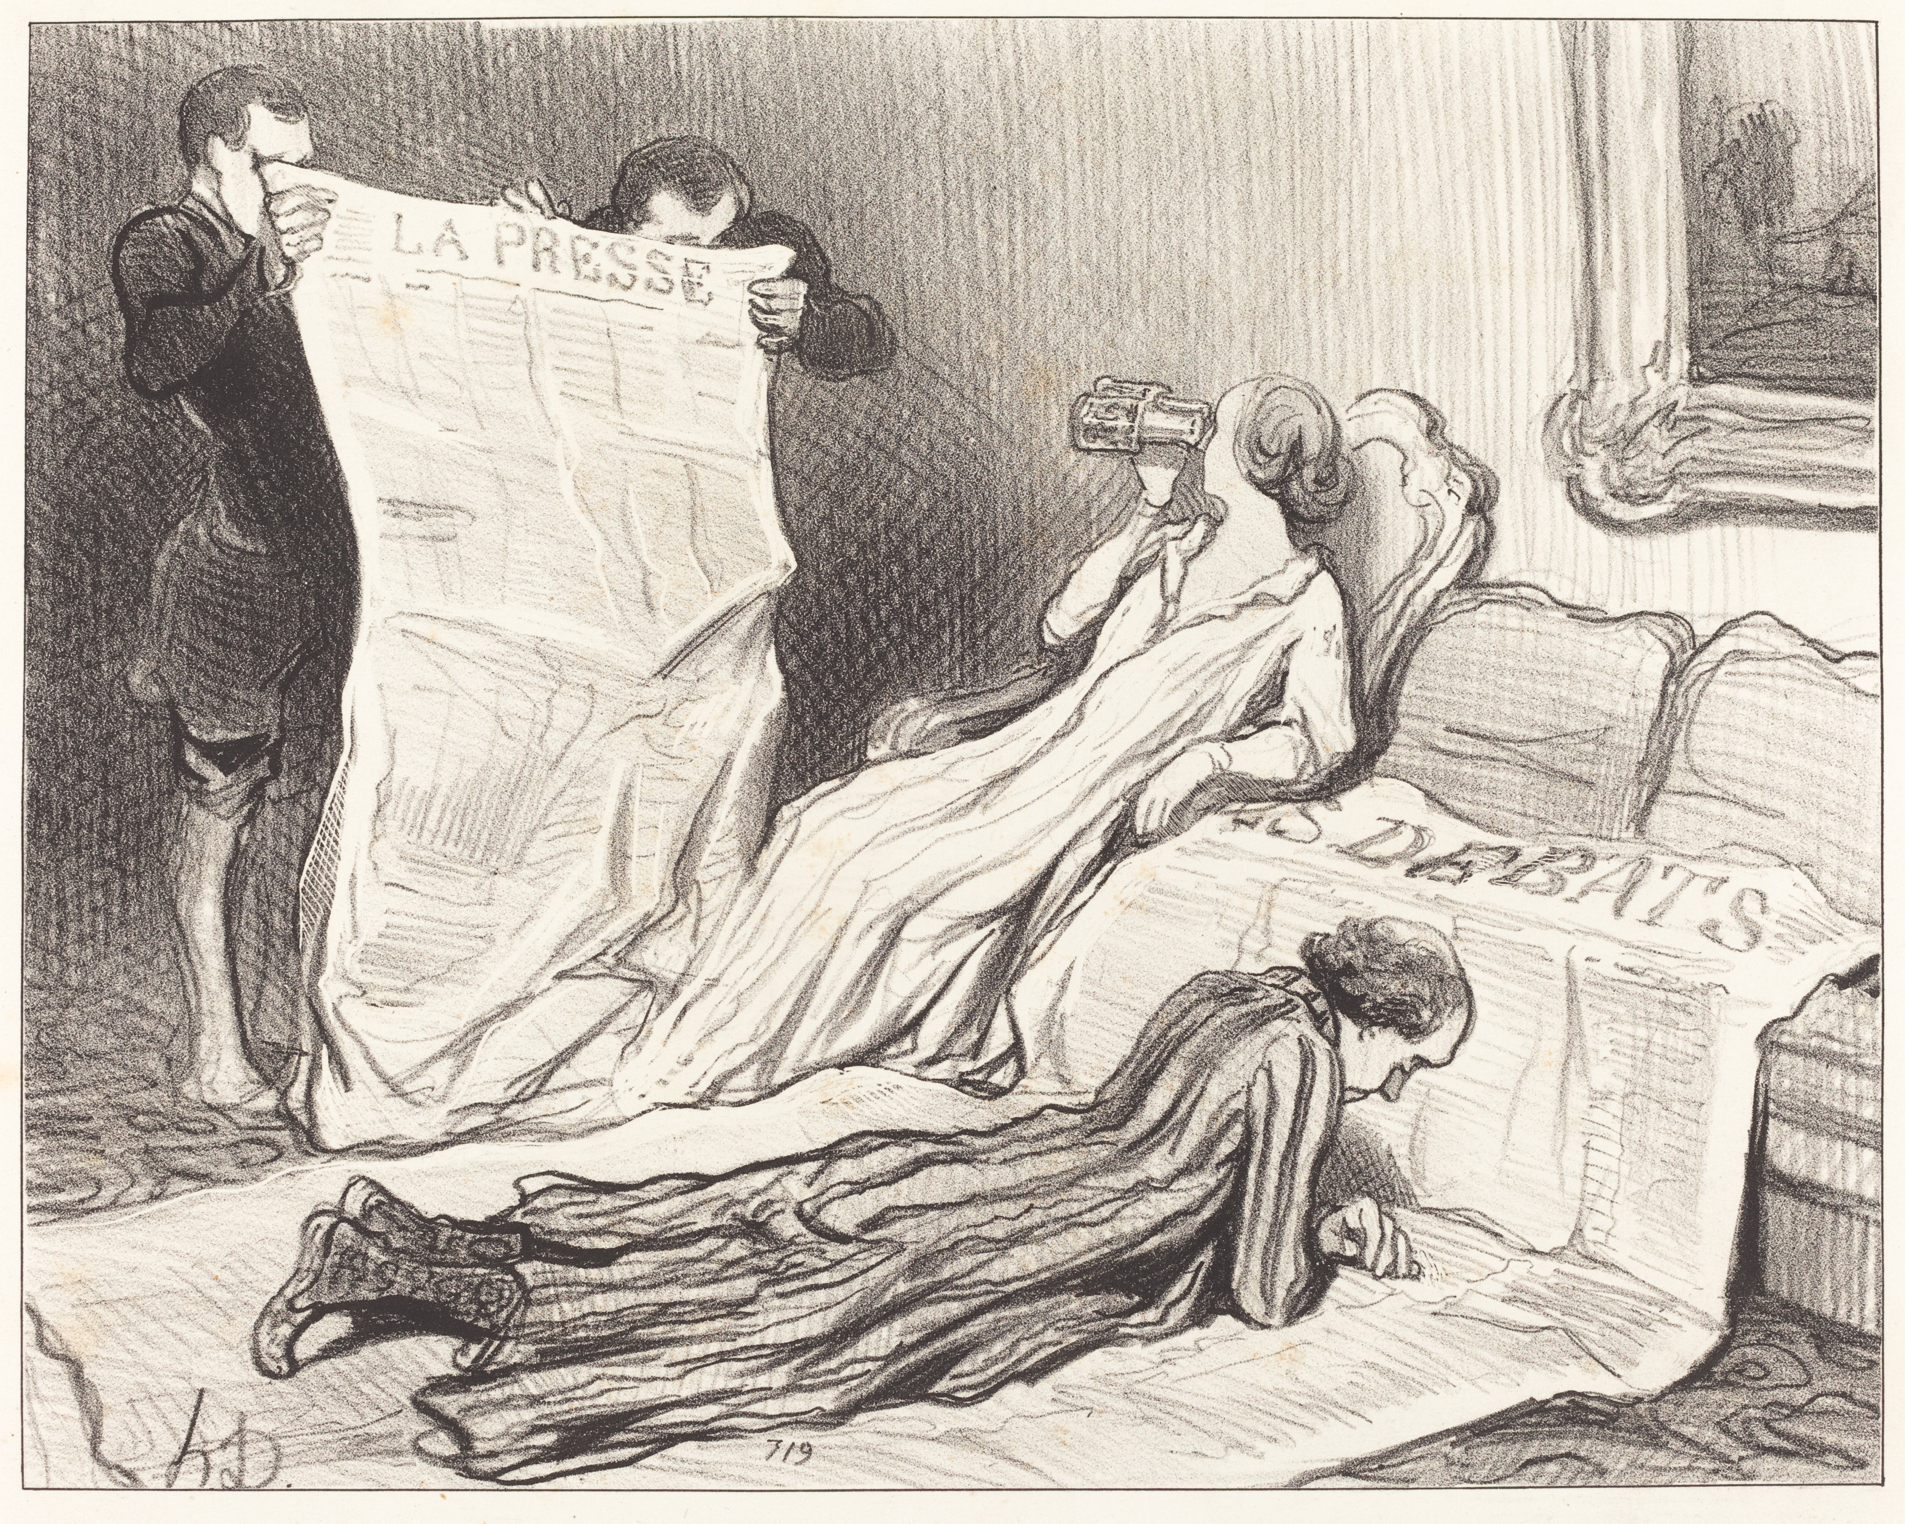
Figure 1. This is a figure. Schemes follow the same formatting.
Title 1 | Title 2 | Title 3
entry 1 | data | data
entry 2 | data | data ¹
Table 1. This is a table. Tables should be placed in the main text near to the first time they are cited.

¹ Tables may have a footer.
The text continues here (Figure 2 and Table 2).
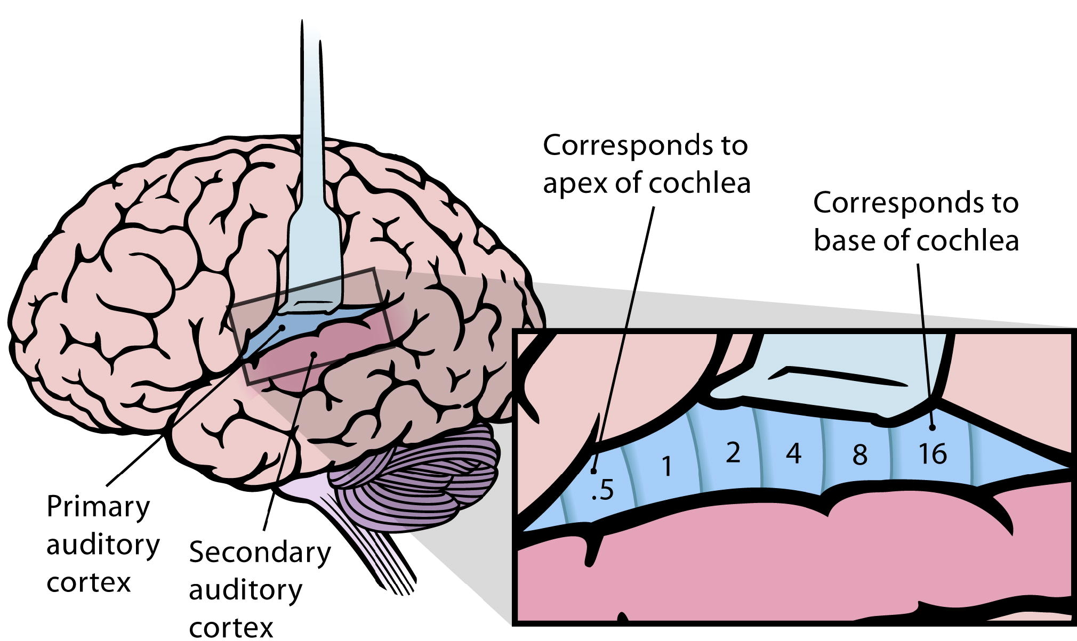 | 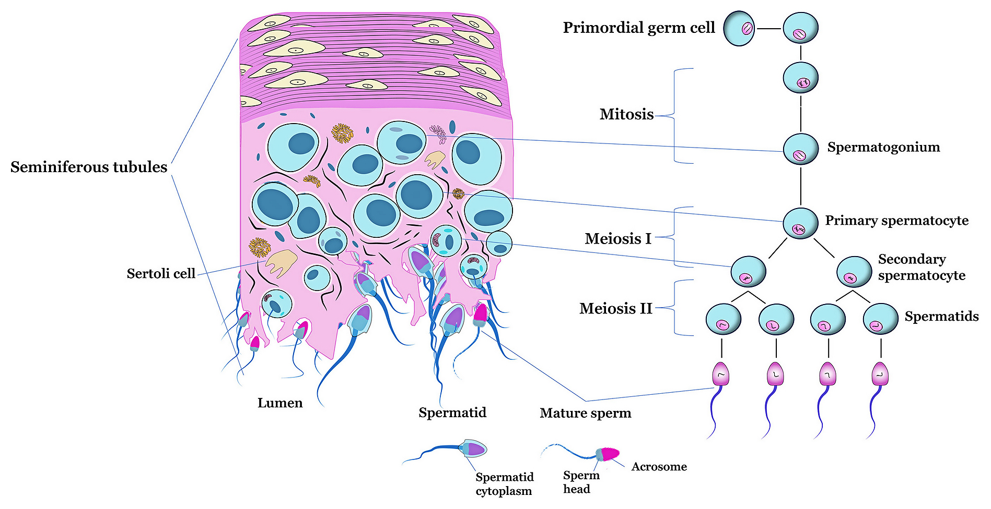
(a) | (b)
Figure 2. This is a figure. Schemes should follow a different format. If the figure contains multiple panels, they should be labeled as follows: (a) Description of the first panel; (b) Description of the second panel. Figures should be positioned in the main text close to where they are first referenced.

Table 2. This is a table. Tables should be placed in the main text near to the first time they are cited.
Title 1 | Title 2 | Title 3 | Title 4
entry 1 * | data | data | data
 | data | data | data
 | data | data | data
entry 2 | data | data | data
 | data | data | data
entry 3 | data | data | data
 | data | data | data
 | data | data | data
 | data | data | data
entry 4 | data | data | data
 | data | data | data
* Tables may have a footer.

3.3. Formatting of Mathematical Components
This is example 1 of an equation:
$\lim_{n→∞}{{\left(1+\frac{1}{n}\right)}^{n}}=2$, | (1)
the text following an equation need not be a new paragraph. Please punctuate equations as regular text.
This is example 2 of an equation:
$$A=πr^{2}$$ | (2)
the text following an equation need not be a new paragraph. Please punctuate equations as regular text.
Theorem-type environments (including propositions, lemmas, corollaries etc.) can be formatted as follows:
Theorem 1. Example text of a theorem. Theorems, propositions, lemmas, etc. should be numbered sequentially (i.e., Proposition 2 follows Theorem 1). Examples or Remarks use the same formatting, but should be numbered separately, so a document may contain Theorem 1, Remark 1 and Example 1.
The text continues here. Proofs must be formatted as follows:
Proof of Theorem 1. Text of the proof. Note that the phrase “of Theorem 1” is optional if it is clear which theorem is being referred to. Always finish a proof with the following symbol. □
The text continues here.

4. Discussion
Authors should interpret the results in relation to previous studies and the working hypotheses. The findings and their broader implications should be discussed in as wide a context as possible. Potential directions for future research may also be suggested.

5. Conclusions
This section is optional but may be included if the discussion is particularly lengthy or complex.
Author Contributions: For research articles with multiple authors, a brief paragraph outlining their individual contributions must be included. The following statements should be used: “Conceptualization, X.X. and Y.Y.; methodology, X.X.; software, X.X.; validation, X.X., Y.Y., and Z.Z.; formal analysis, X.X.; investigation, X.X.; resources, X.X.; data curation, X.X.; writing—original draft preparation, X.X.; writing—review and editing, X.X.; visualization, X.X.; supervision, X.X.; project administration, X.X.; funding acquisition, Y.Y. All authors have read and agreed to the published version of the manuscript.”
Please turn to the CRediT taxonomy for the term explanation. Authorship must be limited to those who have contributed substantially to the work reported.
Funding: Please include the following statement: “This research received no external funding” or “This research was funded by [NAME OF FUNDER], grant number [XXX],” along with “The APC was funded by [XXX].” Ensure that all details are accurate and use the standard spelling of funding agency names as listed at https://search.crossref.org/funding.
Institutional Review Board Statement: In this section, include the Institutional Review Board (IRB) statement and approval number, if applicable to your study. If ethical approval was not required, you may choose to omit this statement. For studies involving humans, include: “The study was conducted in accordance with the Declaration of Helsinki, and approved by the Institutional Review Board (or Ethics Committee) of [NAME OF INSTITUTE] (protocol code [XXX] and date of approval).” For studies involving animals, use: “The animal study protocol was approved by the Institutional Review Board (or Ethics Committee) of [NAME OF INSTITUTE] (protocol code [XXX] and date of approval).” If ethical review and approval were waived, state: “Ethical review and approval were waived for this study due to [REASON] (please provide a detailed justification).” For studies not involving humans or animals, write: “Not applicable.”
Informed Consent Statement: Any research article involving human subjects should include this statement. Please add: “Informed consent was obtained from all subjects involved in the study,” or “Patient consent was waived due to [REASON] (please provide a detailed justification),” or “Not applicable” for studies not involving humans. You may also choose to omit this statement if the study did not involve human subjects.
For studies involving identifiable patients, written informed consent for publication must be obtained. If applicable, please state: “Written informed consent has been obtained from the patient(s) to publish this paper.”
Acknowledgments: In this section, you can acknowledge any assistance that is not included in the author contribution or funding sections. This may involve administrative or technical support, as well as in-kind donations (e.g., materials provided for experiments).
Conflicts of Interest: Declare any conflicts of interest, or state: “The authors declare no conflicts of interest.” Authors must disclose any personal circumstances or interests that could be perceived as influencing the representation or interpretation of the research results. Any involvement of funders in the study design, data collection, analysis, or interpretation, manuscript writing, or decision to publish must be stated in this section. If there was no involvement, please state: “The funders had no role in the design of the study, in the collection, analysis, or interpretation of data, in the writing of the manuscript, or in the decision to publish the results.”

Abbreviations
Abbreviations should be listed here and in alphabetical order of acronyms.
ACS | American Chemical Society
DA | Discriminant analysis
NIH | National Institutes of Health
PLS | Partial least squares

Appendix A

Appendix A.1
The appendix is an optional section that can include supplementary details and data that support the main text. This may include explanations of experimental procedures that are essential for understanding and replicating the research but would disrupt the flow of the main text. Figures showing replicate experiments, which are briefly mentioned in the main text, can be included here or as supplementary data. Additionally, mathematical proofs of results that are not central to the paper may be placed in the appendix.
Table A1. This is a table caption.
Title 1 | Title 2 | Title 3
entry 1 | data | data
entry 2 | data | data ¹

Appendix B
All appendix sections must be cited in the main text. In the appendices, Figures, Tables, etc. should be labeled starting with “A”—e.g., Figure A1, Figure A2, etc.

References
References must be numbered in the order they appear in the text (including citations in tables and figure legends) and listed individually at the end of the manuscript. We recommend using a bibliography software, such as Zotero, to ensure accuracy and avoid errors or duplicate references. Include the digital object identifier (DOI) for all references where available. Please use the Zotero style ‘Elsevier Vancouver (brackets, no "et al.")’ for citations and referencing.
Citations and references in the Supplementary Materials are allowed, as long as they also appear in the main reference list.

1. Challenges and opportunities in implementing clinical decision support systems (CDSS) at scale: Interviews with Australian policymakers. Health Policy and Technology. 2022 Sep 1;11(3):100652.
2. A structure–activity relationship study of quinone compounds with trypanocidal activity. European Journal of Medicinal Chemistry. 2005 Apr 1;40(4):329–38.
3. Computational Methods in General Chemistry: Perceptions of Programming, Prior Experience, and Student Outcomes [Internet]. [cited 2023 Apr 1]. Available from: https://digital.nsta.org/article/Computational+Methods+in+General+Chemistry%3A+Perceptions+of+Programming%2C+Prior+Experience%2C+and+Student+Outcomes/2354061/285569/article.html
4. Yang M, Loeb DF, Sprowell AJ, Trinkley KE. Design and Implementation of a Depression Registry for Primary Care. Am J Med Qual. 2019;34(1):59–66.
5. Detection of Argan Oil Adulteration Using Quantitative Campesterol GC-Analysis | Journal of the American Oil Chemists’ Society. [cited 2024 Apr 2]; Available from: https://link.springer.com/article/10.1007/s11746-007-1084-y
6. Zhang X, Li X, He Y, Law PJ, Farrington SM, Campbell H, Tomlinson IPM, Houlston RS, Dunlop MG, Timofeeva M, Theodoratou E. Phenome-wide association study (PheWAS) of colorectal cancer risk SNP effects on health outcomes in UK Biobank. Br J Cancer. 2021 Dec 15;1–9.

